**AWS EC2 instance Creation**

In order to create an EC2 instance in AWS cloud, the pre-requisites are:

1. VPC creation.
2. Security group creation
3. DHCP options creation.
4. Configure internet gateway.
5. Configure Rout Table.

Step1: Create the Virtual private cloud (VPC).

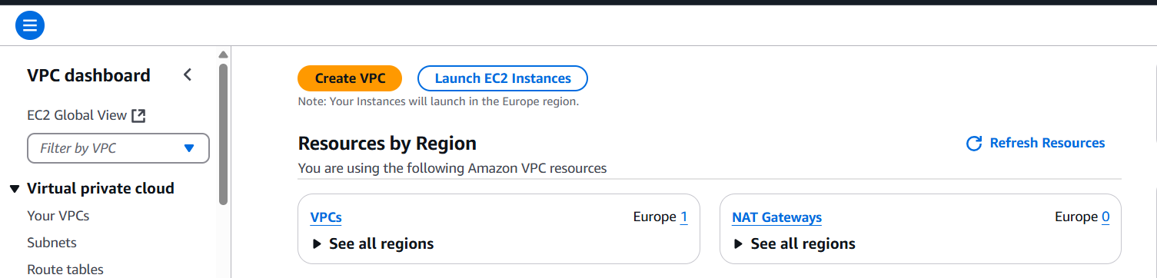

Fig: Create a VPC.

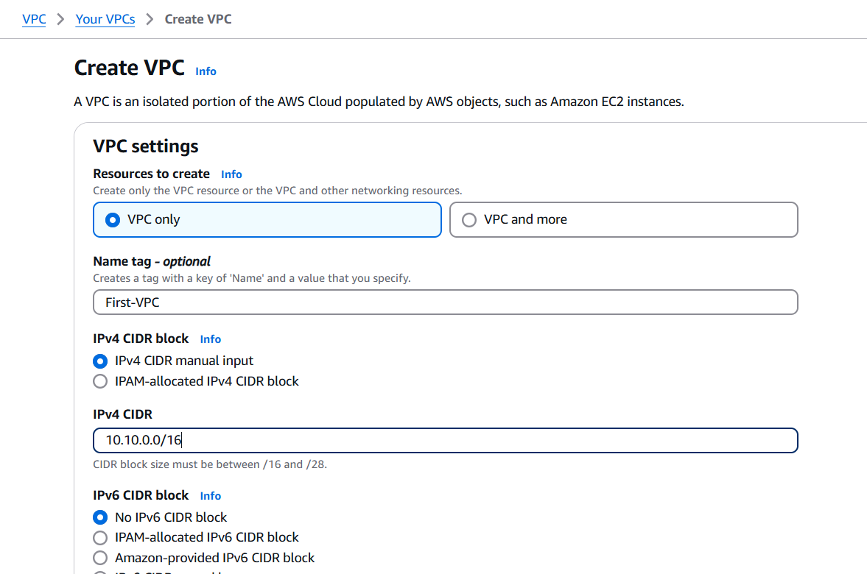

Fig: Create VPC only.

**Note:** If we choose **“VPC and more”** it will automatically create Route Table, Subnet, Network connection including with VPC as shown in below figure.

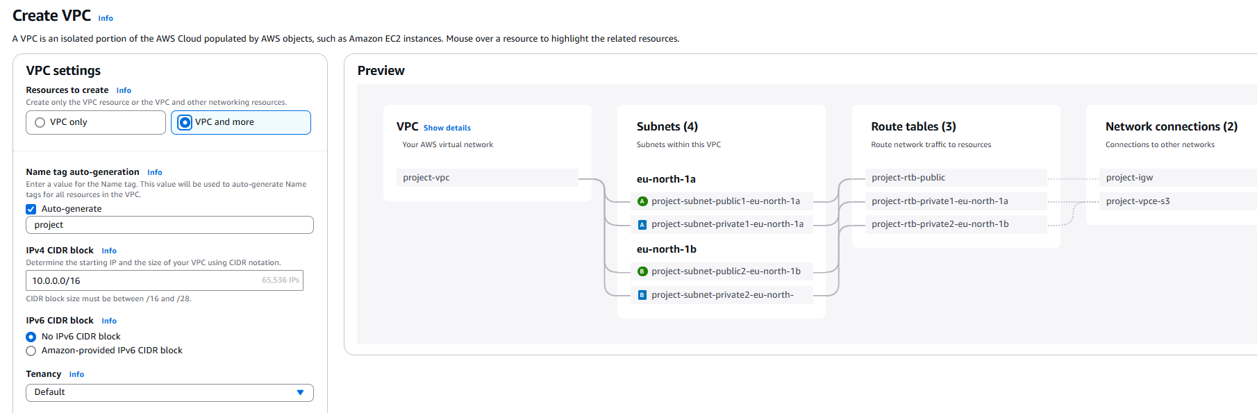

Fig: VPC and more.

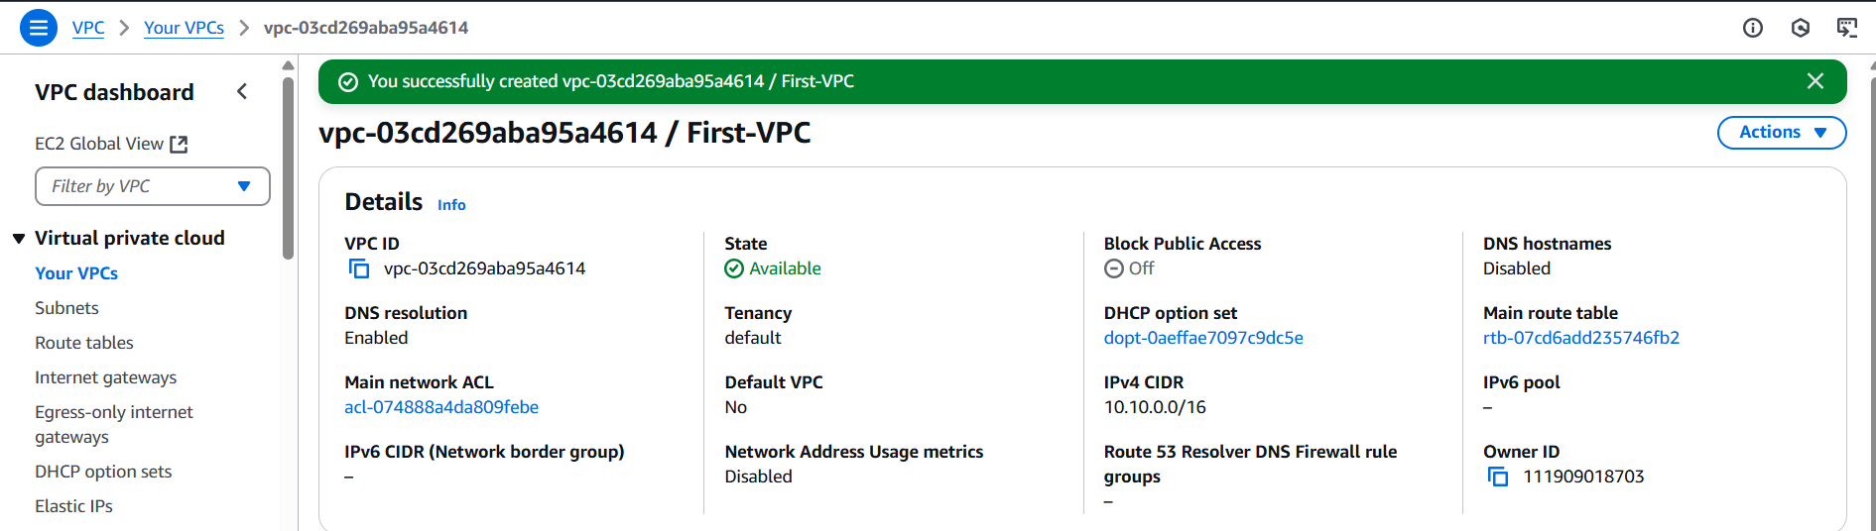

Fig: VPC is created with name (First-VPC).

**Step2:** Create a Subnet within the VPC (First-VPC).

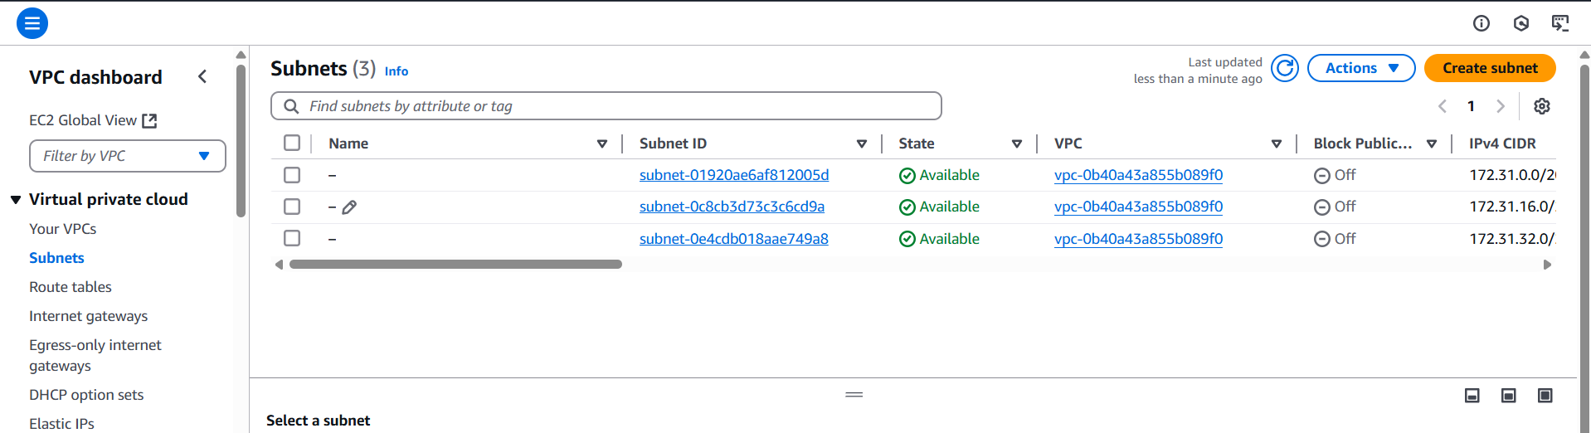

Fig: Create Subnet.

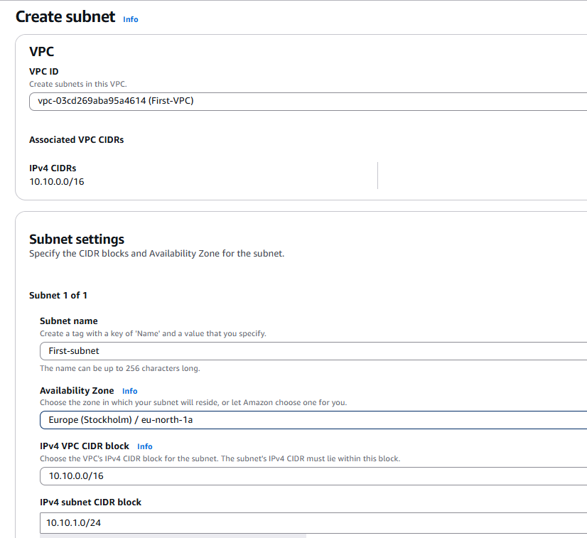

Fig: Configuring of subnet.

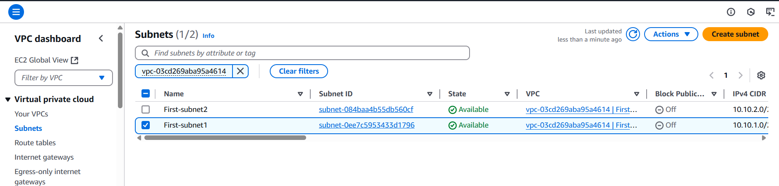

Fig: Two Subnets are created with name First-subnet1 & First-subnet2.

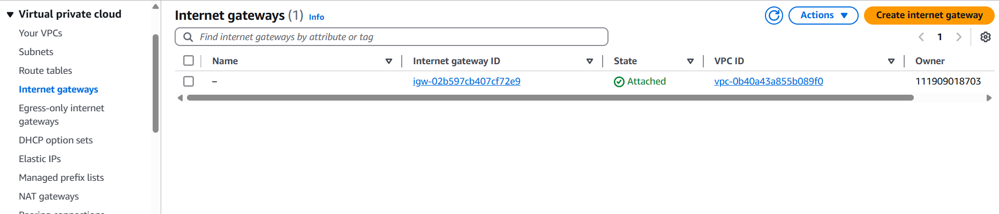**Step3:** Create internet gateway (IGW).

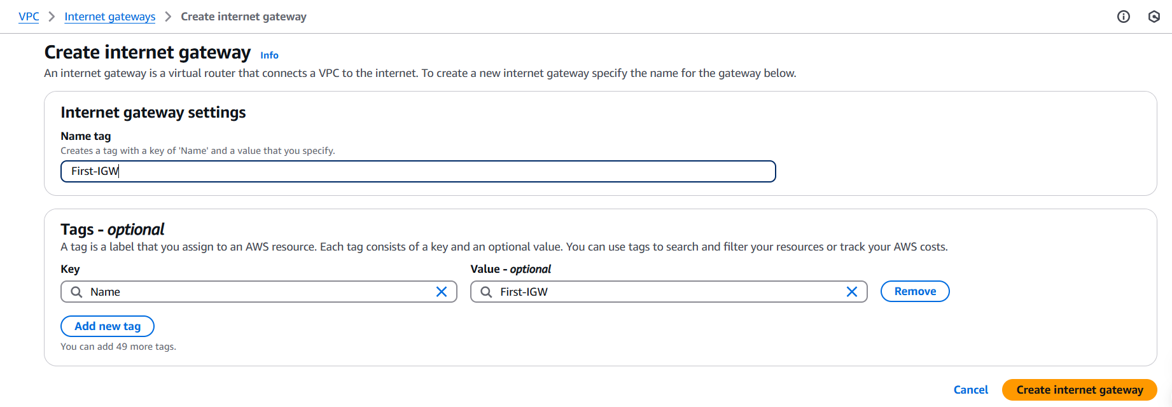

Fig: Create the internet gate way with name First-IGW.

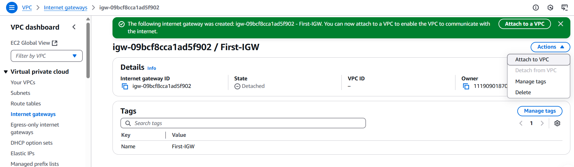

Fig: Internet gateway is created successfully.

**Note:** When we create an internet gateway (IGW) it won’t attached to the VPC by default, we have to attach it manually to the specific VPC.

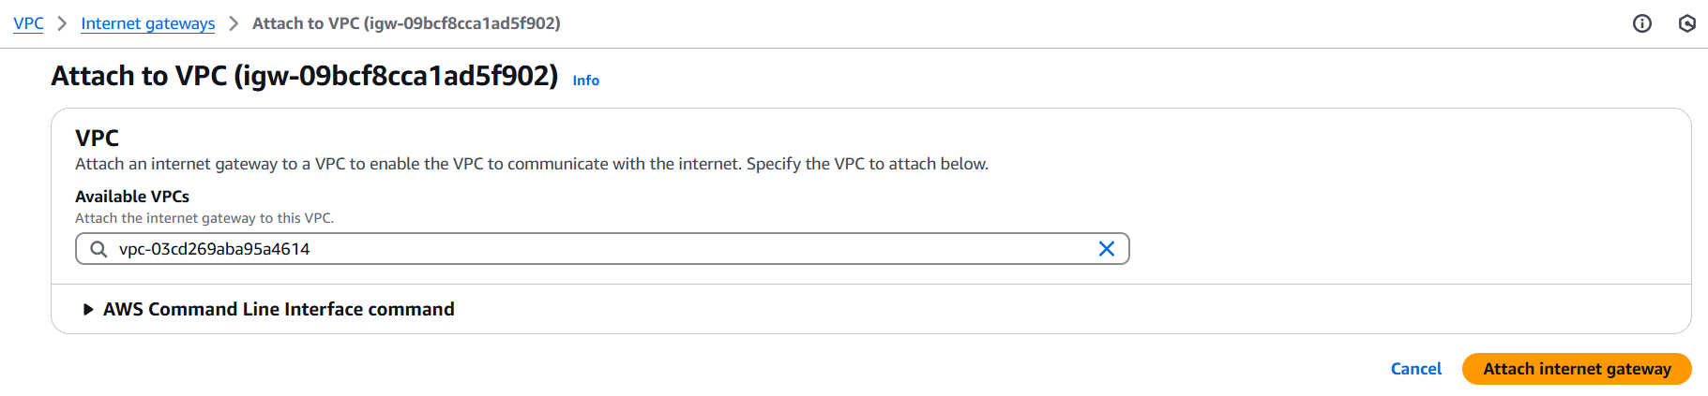

Fig: Attaching the Internet gateway (First-IGW) to the VPC (First-VPC).

**Step4:** Create a Route table.

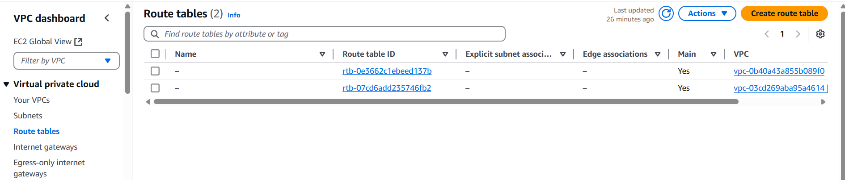

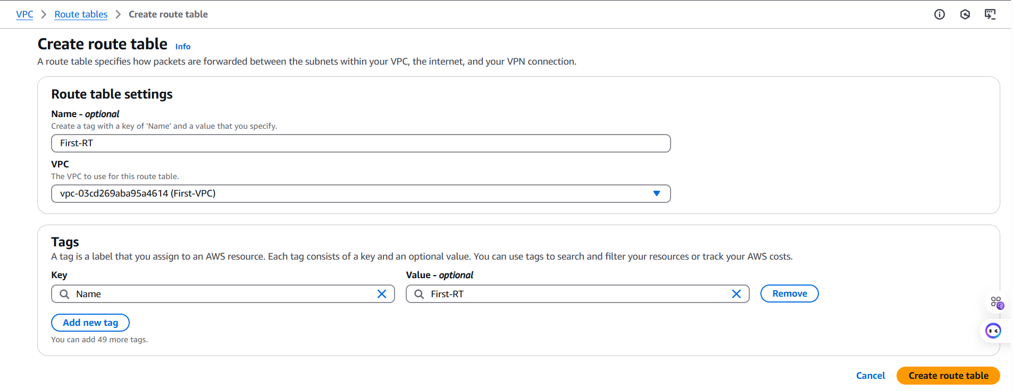

Fig: Configure and Create Route Table.

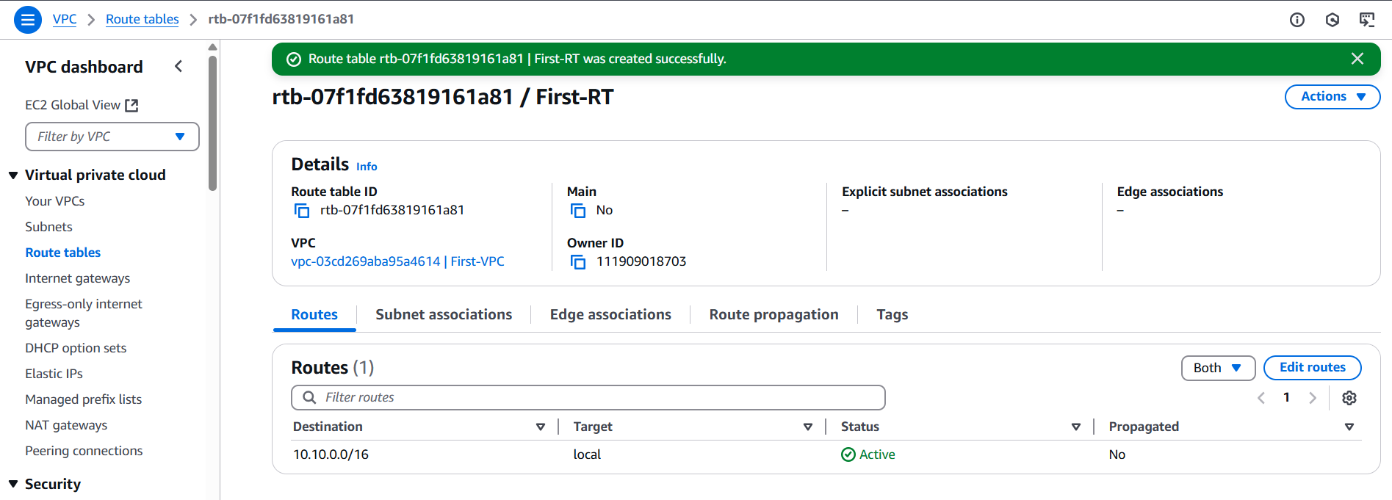

Fig: Route Table is created successfully.

"Now “edit the routes” to allow configuring the traffic path — whether it should connect externally or internally."

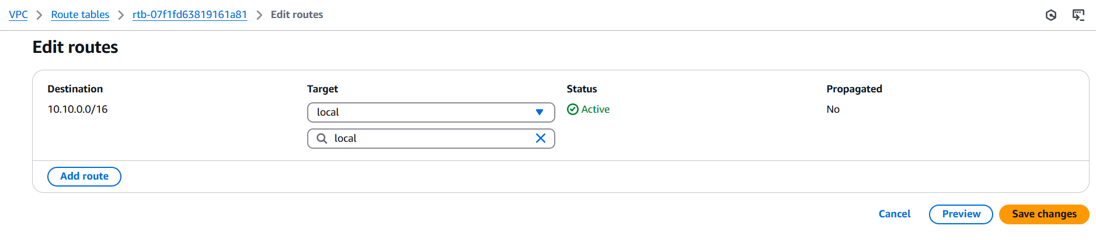

Fig: Default rote rule in Rout Table.

The above default route rule says that whatever resources present inside the VPC should communicate or connect each other locally.

Now add the route rule to connect or communicate the resources of VPC (or any traffic 0.0.0.0/0) to the external using Internet gateway as shown below figure.

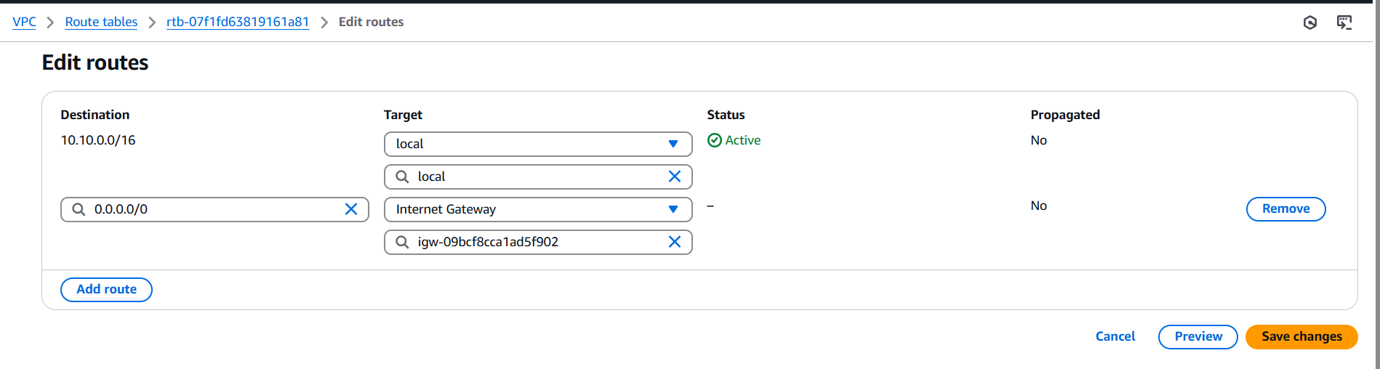

Now the any traffic is uses the internet gateway to connect to the external (like google, public internet websites).

**Note:** Use only default Route Table.

**Step5:** Create a Security Group.

**Note:** When we create a VPC by default security group also created.

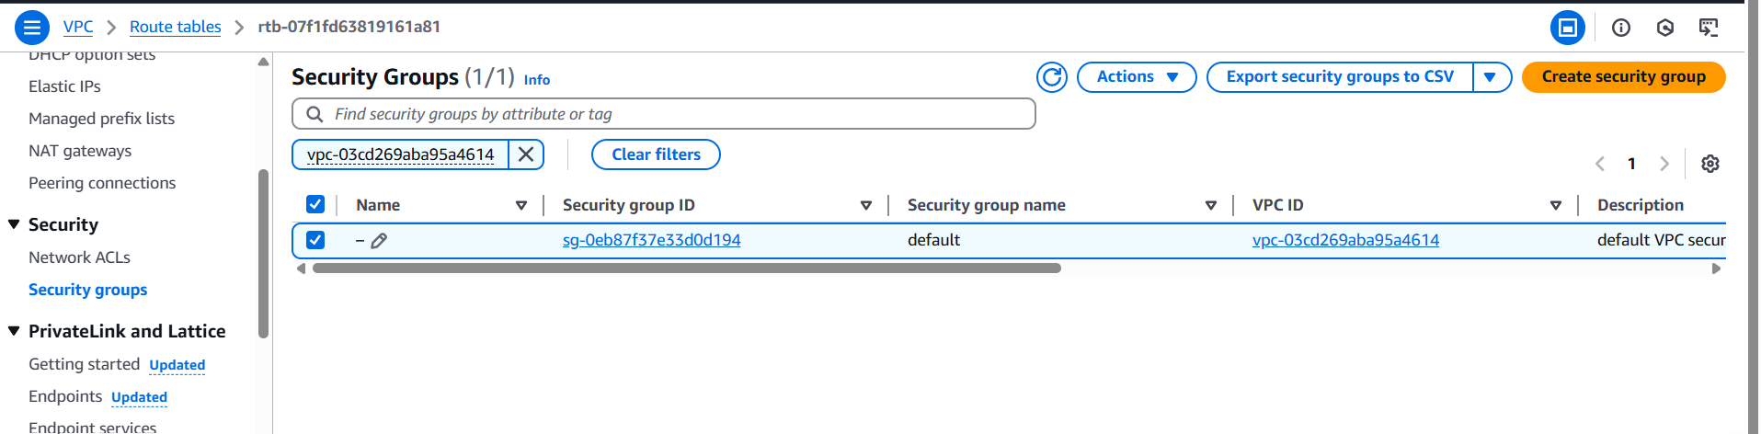

Fig: Security group is created without the name.

We can name the security group by edit option as shown in above figure.

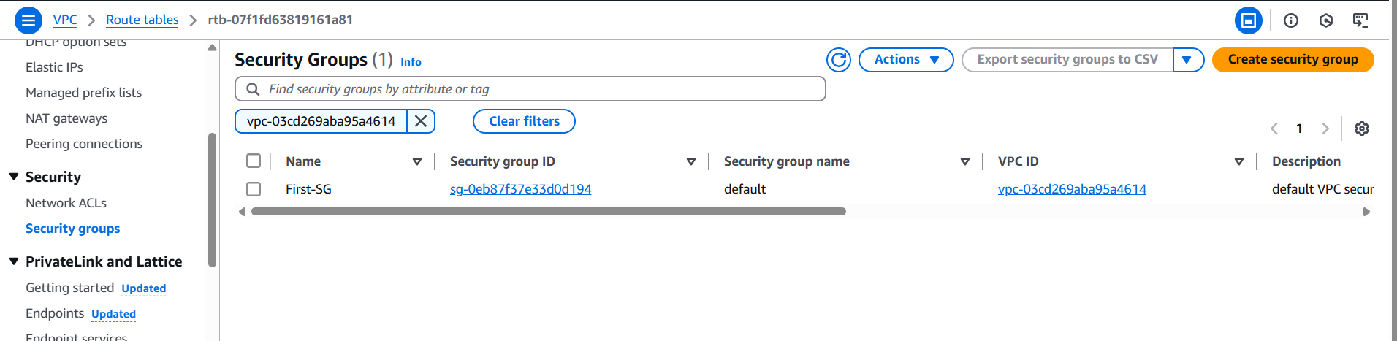

Now edit the inbound rules in such a way to allow any traffic.

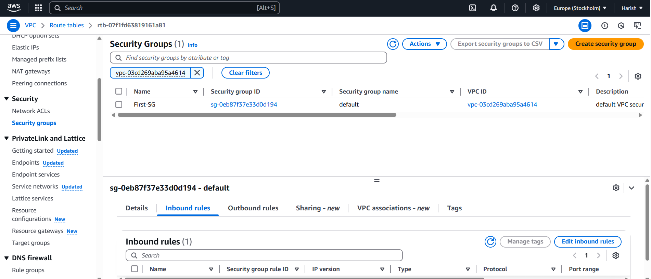

Fig: Edit inbound rules.

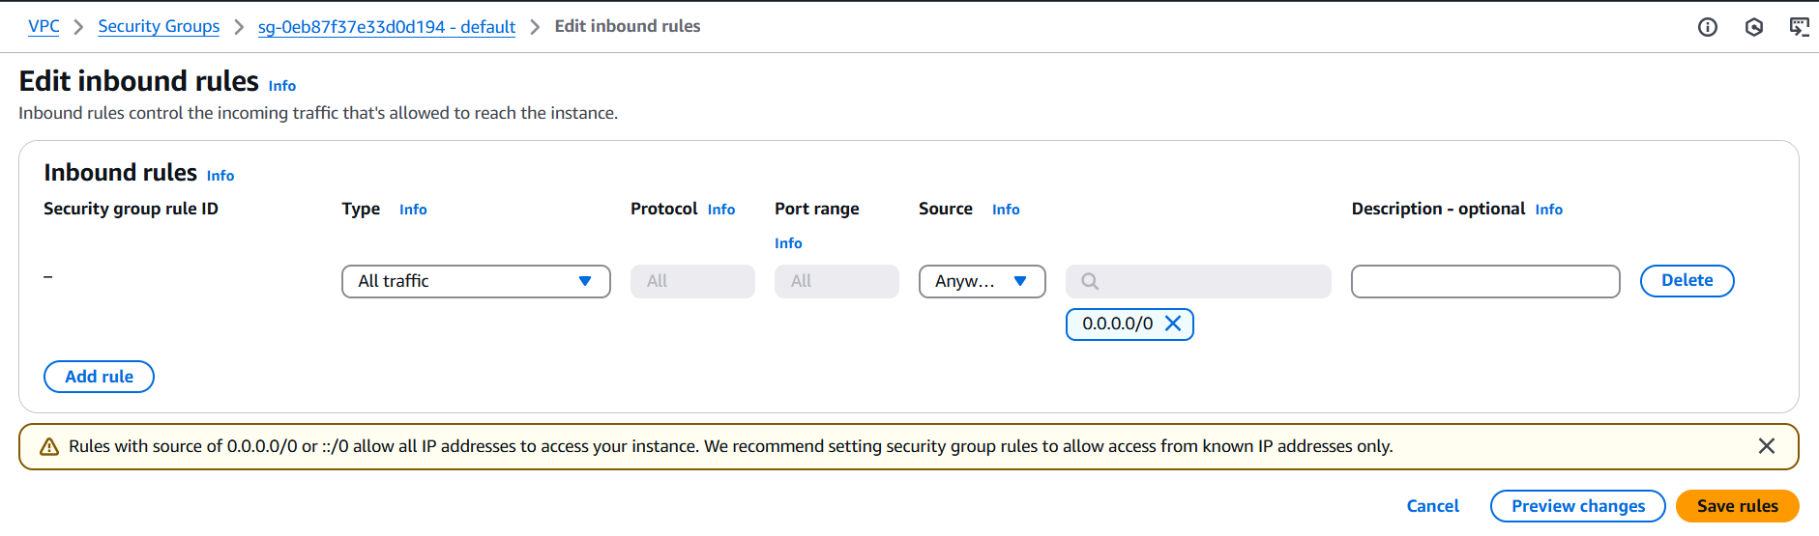

Fig: Allowing All traffic of IPV4.

Up to Now I created a basic infrastructure which is required to create an EC2 instance in AWS cloud. Now let’s create an EC2 instance.

**Step6:** Create an EC2 instance.

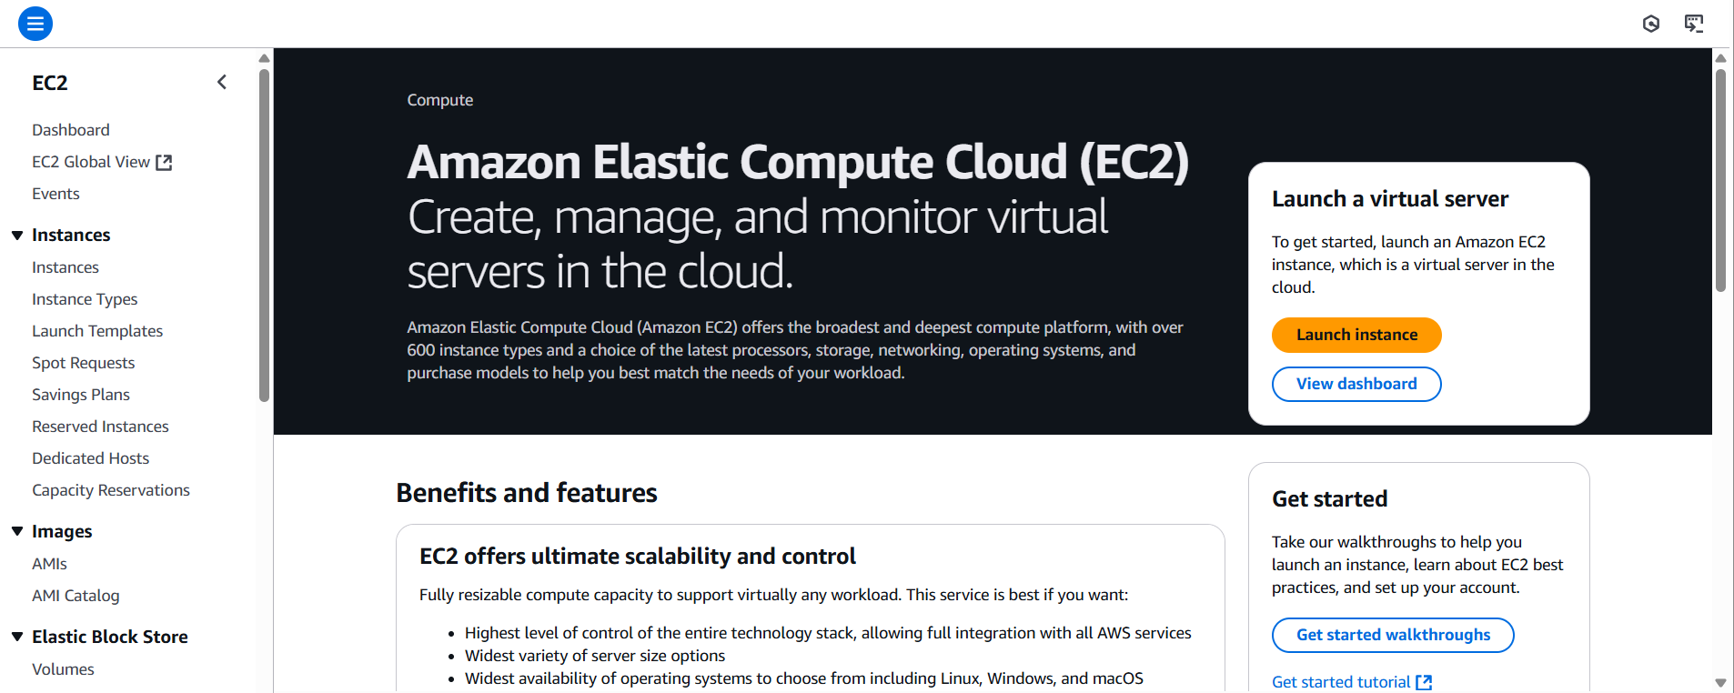

**Note:** While creating the instances just choose OS and Instances type which as free tier eligibility, so that cost/billing cannot be increased.

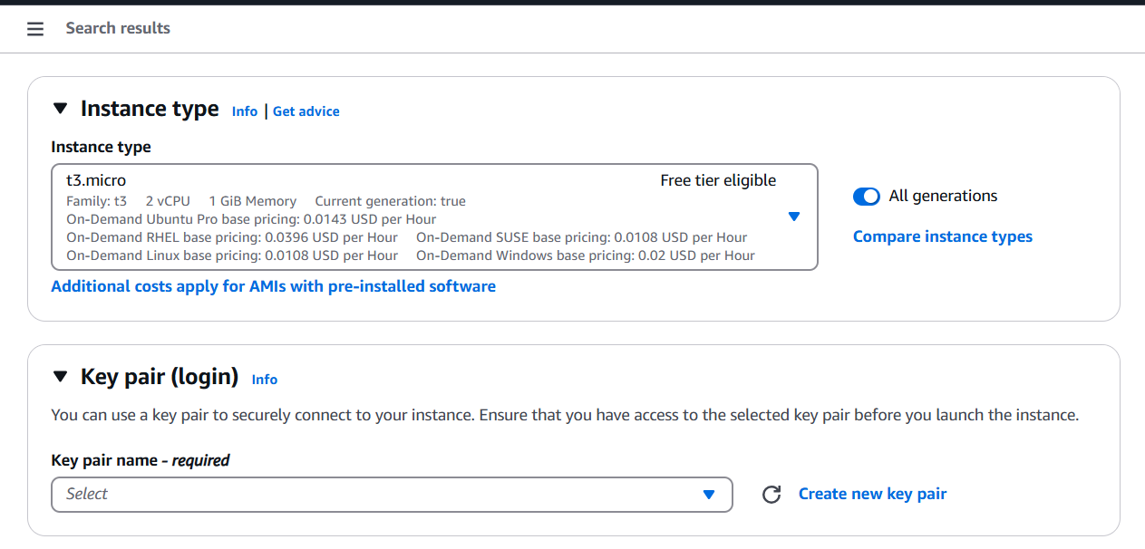

Fig: Create a Key pair.

**Note:** When we create a key pair a file with extension “.**pem”** is downloads in our local machine

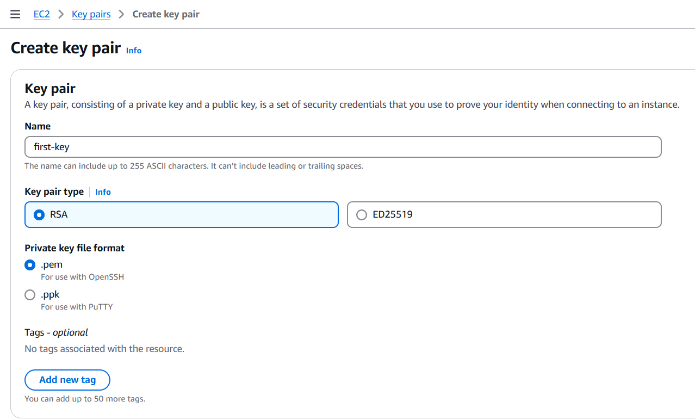

In AWS we only use key pair to login into the EC2 instances not the password and user name.

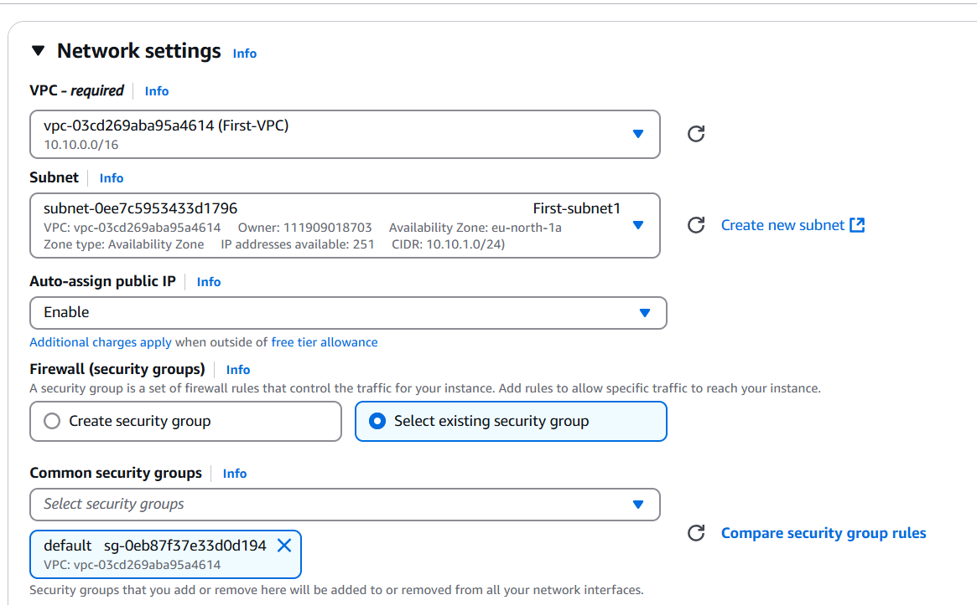

Fig: Configuring Network settings of instance-01.

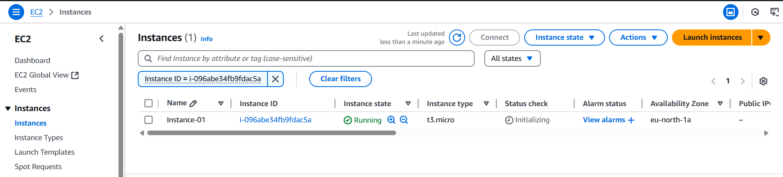

Fig: EC2 instance (instance-01) is created successfully.

Step7: Login into the Instance-01 using key pair with puttygen.exe tool.

We usually use the .ppk file to login into the EC2 instance, to conver the .pem file to .ppk file we uses the puttygen.exe tool.

Open the puttygen.exe tool🡺select “All Files” 🡺Load (load the .pem file)🡺save private key with .ppk extension. So that .pem file is converted into .ppk file

Now then open the putty.exe tool🡺past instance public IP🡺SSH🡺Auth🡺Browse the .ppk local file🡺open.

We can also use “MobaXterm” tool to login into the EC2 instances using key pair as show below figure.

Open MobaXtrem🡺session🡺 SSH🡺 past instance public IP at Remote host🡺username:Ubuntu🡺Advance SSH settings🡺Enable “Use private key🡺Browse the .ppk file pathe 🡺 click “OK”.

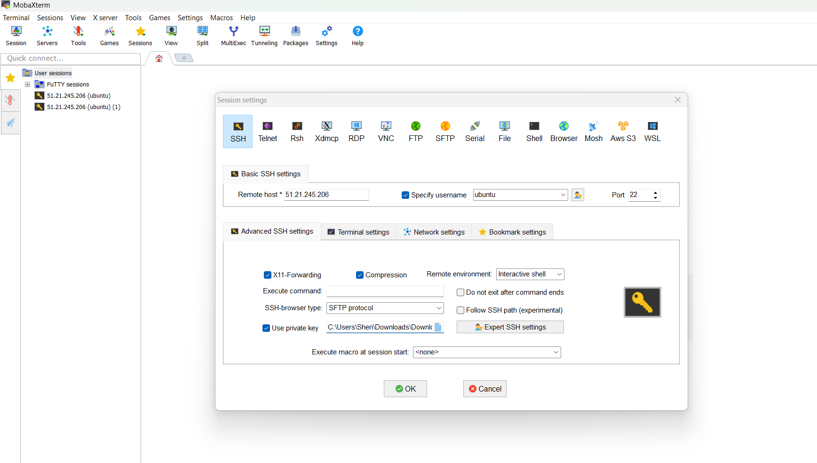

Fig: MobaXtrem tool to connect to the instance

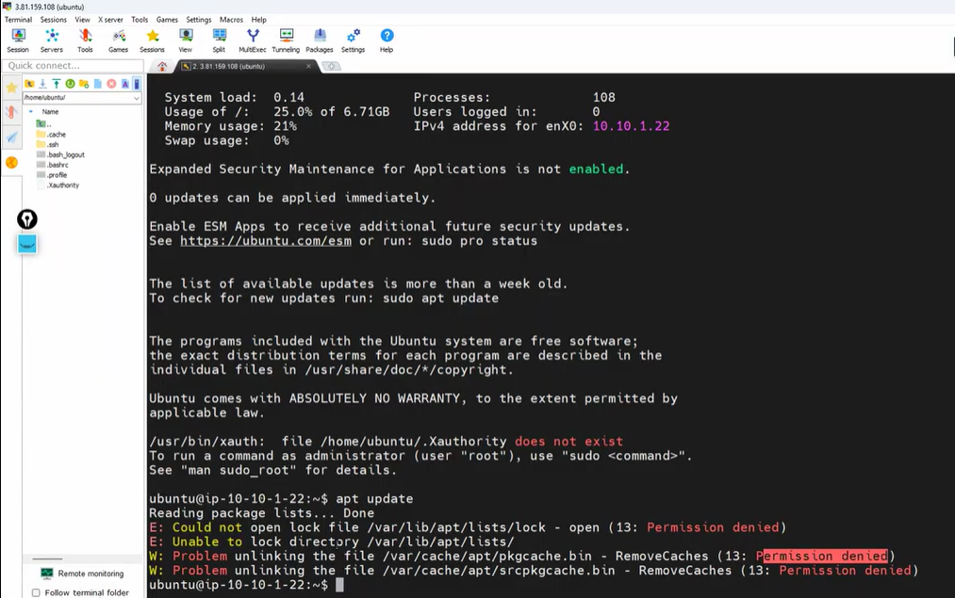

Fig: Successfully login into the instance using MobaXtrem tool.

Block Diagram:

Internet

10.10.0.0/16🡪Locally

0.0.0.0/0 🡪 use internet gateway

Rout

Table

Internet

Gateway

First-subnet2

First-subnet1

First-VPC

Instance-01

Instance-01

**10.10.0.0/16 🡪Locally:**

It says that the resources which are belongs to CIDR number 10.10.0.0/16 should communicate within the VPC only.

**0.0.0.0/0🡪 Use internet gateway:**

Any traffic originating from a subnet associated with this route table that is destined for any IPv4 address on the internet (0.0.0.0/0) should be routed to the specified Internet Gateway.

**Note:** While creating the VPC by default Rout Table, DHCP, and Security group is created with it.